APACHE KAFKA
Agenda:
- Creating a kafka cluster with 3 brokers
- Set up kafka with docker
- In Sync Replication
- Kafka, Schema Registry, and the Importance of Data Validation
- Kafka in Microservices architecture
Create a Kafka Cluster with 3 Brokers on cmd:
1. Start ZooKeeper
- Navigate to Kafka’s bin directory.
Run the following command to start ZooKeeper:
kafka-server-start.bat ..\..\config\zookeeper.properties
2. Set Up Multiple Brokers
- Go to the config directory.
- Copy server.properties and create two more copies:
  - server1.properties
  - server2.properties
- Modify each file:
  - Unique broker.id (e.g., 0, 1, 2).
  - Different ports (e.g., 9092, 9093, 9094).
  - Unique log directories (e.g., /logs/kafka-broker-1/, /logs/kafka-broker-2/, etc.).
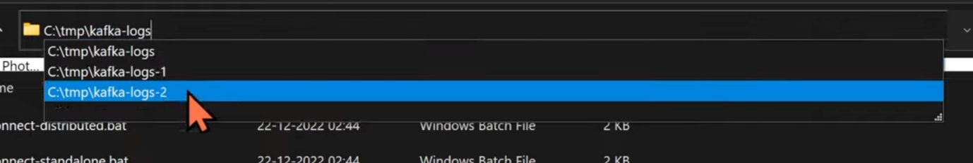
3. Start Kafka Brokers
Run each broker separately in a new terminal:
- This will open three brokers and one ZooKeeper window.
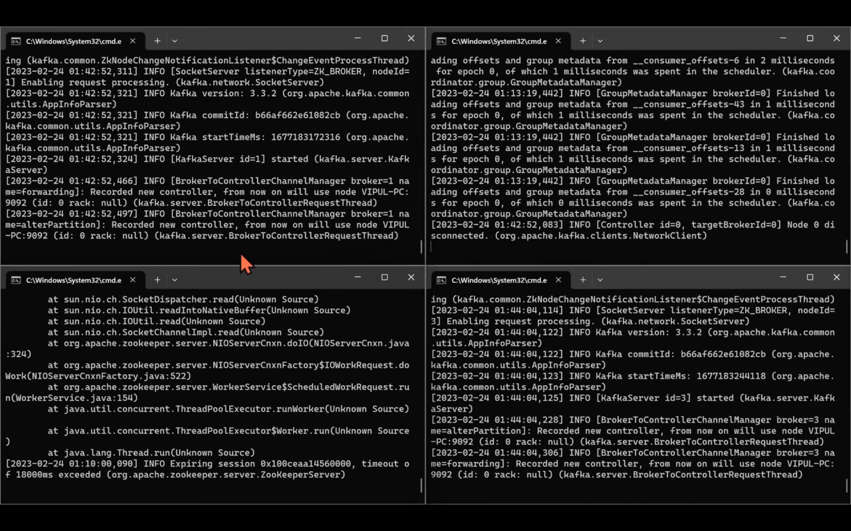
4. Verify the Cluster
- Kafka will create log files for all three brokers.
- All brokers will share the same ZooKeeper instance for communication.
5. Create a Kafka Topic
Open another terminal and run:
- Replication factor = 3 ensures fault tolerance by maintaining three copies of the data across brokers.
6. Kafka Without ZooKeeper (New Versions)
- Instead of ZooKeeper, use --bootstrap-server to create and manage topics.

Kafka and Zookeeper with Docker:
Step 1: Install Docker and Docker Compose
Before running Kafka on Docker, ensure you have Docker and Docker Compose installed.
- Install Docker: Download and install Docker from Docker’s official website.
Install Docker Compose (if not included in Docker Desktop)
Tip: Increase Docker’s memory allocation from 2GB to 4GB or 8GB for better performance.
Step 2: Clone a Sample Kafka Docker Project
Clone a sample Kafka Docker setup:
Alternatively, download a ZIP file from a similar GitHub repository.
Step 3: Stop Existing Kafka/Zookeeper Instances
If Kafka or Zookeeper is already running, stop them:
Step 4: Start Kafka and Zookeeper using Docker Compose
Kafka relies on Zookeeper, so we'll start both with a single command.
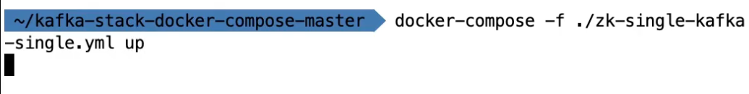
Using Docker Compose
- The -d flag runs the containers in detached mode (background).
- This will pull images, set up Zookeeper, and start Kafka.
This process might take a while as Docker downloads and sets up everything.
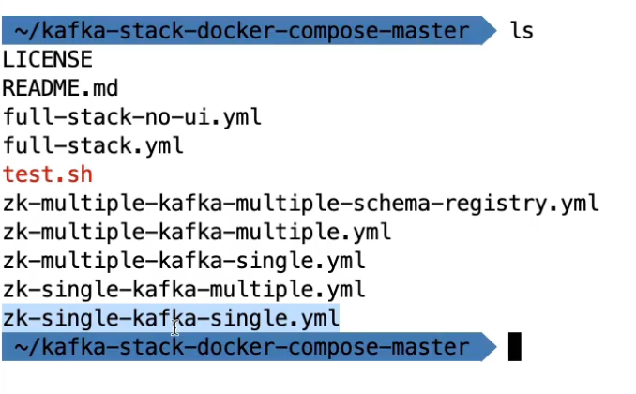
This shows that there is one zookeeper and one kafka running on cmd.
Step 5: Verify Kafka and Zookeeper are Running
To check the status of Kafka and Zookeeper, run:
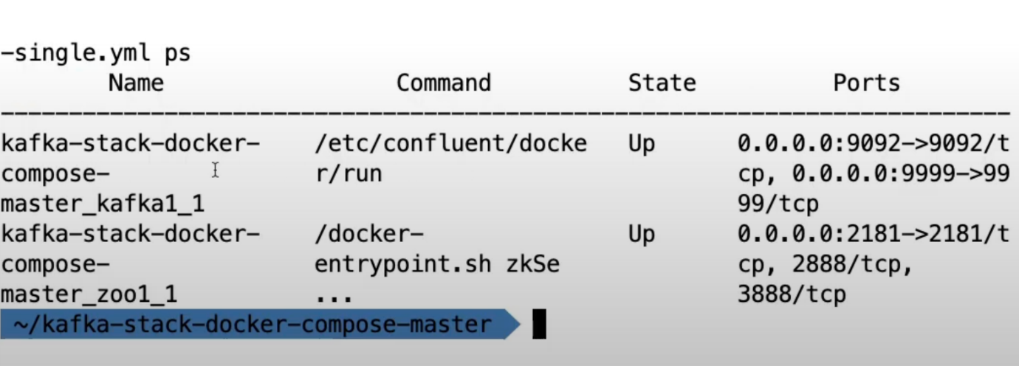
This lists active containers. You should see:
- zookeeper running on port 2181
- kafka running on port 9092
Now you can Interact with Kafka and make changes according to your preferences.
In-Sync Replication (ISR) in Kafka
In-Sync Replication (ISR)
- ISR (In-Sync Replicas) refers to the set of replicas that are fully synchronized with the leader partition.
- It ensures data consistency and fault tolerance in Kafka.
- Followers in ISR replicate data from the leader to stay updated.
2. How Replication Works?
- Each partition has one leader that handles all read and write requests.
- Other brokers act as followers and replicate data from the leader.
- Kafka maintains multiple copies (replicas) of each partition based on the replication factor.
- If a leader broker fails, Kafka elects a new leader from the in-sync replicas.
3. Kafka Topic and ISR Example
- Topic Name: Gadgets
- Partitions: 3
- Replication Factor: 3
- Example of partition leadership and replication:
  - Partition 0: Leader → Broker 0, Replicas → 3, 1, 0
  - Partition 1: Leader → Broker 3, Replicas → 0, 3, 1
  - Partition 2: Leader → Broker 1, Replicas → 1, 0, 3
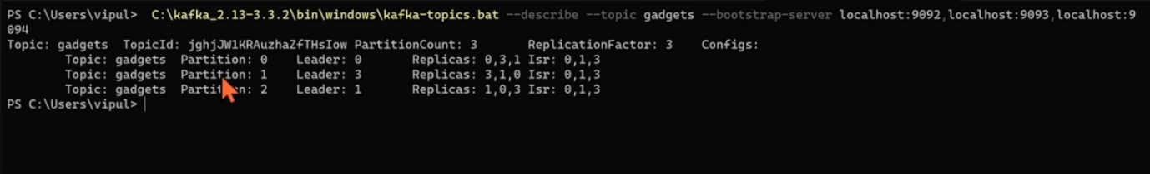
4. Role of ISR in Fault Tolerance
- All ISR members continuously sync with the leader.
- If a follower lags behind or fails, it is temporarily removed from ISR.
- If a leader goes down, Kafka elects a new leader from the ISR.
- Example:
  - If Broker 3 goes down, new leadership assignments occur, and ISR updates.
  - Partition leaders are reassigned among the remaining brokers.
5. Commands to Check ISR and Partition Details
Describe a Kafka topic:
kafka-topics.sh --describe --topic gadgets --bootstrap-server localhost:9092
- Check partition leadership, replicas, and ISR:
  - Shows which broker is the leader for each partition.
  - Lists all replica brokers and the in-sync replicas.
Kafka, Schema Registry, and the Importance of Data Validation
Kafka is a high-performance message broker that processes and distributes data efficiently. However, by default, Kafka only handles raw bytes (zeros and ones) without verifying or enforcing data structures. This is both a strength and a limitation.
Kafka’s Default Behavior (Handling Raw Bytes)
Kafka does not verify, parse, or validate the data it receives. Instead, it simply:
- Accepts serialized bytes from producers.
- Stores them in topics without interpreting them.
- Delivers them to consumers as raw bytes.
Why is this an issue?
- If a producer changes the data format (e.g., renaming a field), consumers will break.
- There is no way to enforce a data structure, meaning corrupted or incorrect data can be produced.
- Schema evolution (changing data formats over time) is difficult without breaking consumers.
To address these challenges, we need a Schema Registry.
Why Kafka Doesn’t Verify Data Internally
A natural question arises:Why doesn’t Kafka itself enforce data validation?
The answer lies in Kafka’s architecture and performance optimizations:
- Kafka is optimized for speed and handles messages in a zero-copy manner.
- It never loads data into Java memory. Instead, it:
  - Reads raw bytes from the network socket.
  - Stores them directly in RAM.
  - Sends them out again through another network socket.
- If Kafka were to parse and validate data, it would introduce CPU overhead and slow down processing.
Thus, Kafka remains agnostic to data formats and simply distributes raw bytes.
The Role of Schema Registry
A Schema Registry solves the data validation problem by acting as an external service that manages and enforces schemas.
How Schema Registry Works
- Producers Register a Schema:
  - Before sending data to Kafka, producers define and register a schema (e.g., Avro, JSON Schema, or Protobuf).
  - This ensures a standard structure for messages.
- Producers Send Data with Schema Reference:
  - Instead of including the full schema in every message, producers send:
    - Only the data (serialized).
    - A schema identifier (stored separately in Schema Registry).
- Consumers Retrieve and Use the Schema:
  - Consumers fetch the schema from Schema Registry.
  - They deserialize the raw bytes into a structured format using the correct schema.
Benefits of Schema Registry
- Data Validation: Prevents corrupted or incorrect data from being produced.
- Schema Evolution: Allows changes in data structure while maintaining compatibility.
- Smaller Payloads: Since the schema is stored separately, only the schema ID is sent with messages, reducing Kafka storage and bandwidth usage.
Schema Compatibility and Evolution
The Schema Registry enforces compatibility rules to ensure backward and forward compatibility:
- Backward Compatibility:
  - Consumers using an older schema can still read messages written with a newer schema.
  - This means new fields can be added, but existing fields cannot be removed or changed.
- Forward Compatibility:
  - Consumers using a newer schema can read messages written with an older schema.
  - This allows removing optional fields but prevents adding mandatory fields.
- Full Compatibility:
  - Ensures both backward and forward compatibility.
  - The safest but most restrictive option.
Kafka Pipelines Without and With Schema Registry
Without Schema Registry
- Producers send raw bytes.
- Kafka stores the bytes as they are.
- Consumers receive raw bytes and must guess the format.
This is risky because any format change can break consumers.
With Schema Registry
- Producers:
  - Serialize data (e.g., Avro).
  - Send schema to Schema Registry.
  - Send only data + schema ID to Kafka.
- Consumers:
  - Retrieve the schema from Schema Registry.
  - Deserialize messages correctly.
This ensures safe schema evolution and prevents data corruption.
Supported Schema Formats
Schema Registry supports three major data formats:
- Apache Avro (most common)
  - Compact and fast
  - Strong support for schema evolution
  - Requires Avro serialization/deserialization
- JSON Schema
  - Human-readable
  - Less compact than Avro
  - Good for APIs
- Protocol Buffers (Protobuf)
  - Compact and efficient
  - Strong cross-language compatibility
  - Ideal for microservices
Apache Avro is the most widely used format for Kafka Schema Registry due to its small size and schema evolution support.
Schema Registry Deployment and Usage
To use Schema Registry:
- Deploy Schema Registry alongside Kafka
  - Schema Registry is a separate service (not built into Kafka).
  - Needs high availability to prevent downtime.
- Update Producer and Consumer Code
  - Producers must serialize data and send schemas.
  - Consumers must fetch schemas and deserialize data.
- Learn Schema Formats (Avro, JSON Schema, Protobuf)
  - Avro is common but has a learning curve.
  - Protobuf and JSON Schema are alternatives.
Licensing and Open Source Considerations
- Schema Registry is not fully open source.
  - It is source-available (you can view the code).
  - However, you cannot resell it as a service.
- Created by Confluent, not Apache Kafka.
  - Confluent is a private company that develops Kafka-related tools.
  - Apache Kafka itself does not include a Schema Registry.
Kafka in Microservices Architecture:
Integrating Apache Kafka into a microservices architecture brings several benefits that enhance scalability, flexibility, and fault tolerance. Let’s delve deeper into these advantages:
Event-Driven Communication:
Kafka’s publish-subscribe model allows services to communicate through events. Producers publish events to Kafka topics, and consumers subscribe to the relevant topics, enabling asynchronous and decoupled communication. This event-driven approach enhances scalability and allows for loose coupling between services.
This Python code replicates the functionality of your Java Kafka producer, publishing a message to a Kafka topic. It uses the confluent_kafka library, which you can install using:
pip install confluent-kafka

from confluent_kafka import Producer
def delivery_report(err, msg):
if err is not None:
print(f"Message delivery failed: {err}")
else:
print(f"Message delivered to {msg.topic()} [{msg.partition()}]")
# Configure the Kafka producer
conf = {
'bootstrap.servers': 'localhost:9092',
'key.serializer': str.encode,
'value.serializer': str.encode
}
# Create a Kafka producer instance
producer = Producer({'bootstrap.servers': conf['bootstrap.servers']})
try:
# Send a sample event to a Kafka topic
topic = "my-topic"
key = "event-key"
value = "Sample event message"
producer.produce(topic, key=key, value=value, callback=delivery_report)
producer.flush() # Ensure all messages are delivered
print("Event published successfully to Kafka.")
except Exception as e:
print(f"Error: {e}")
Import Kafka Library
- from confluent_kafka import Producer imports the Kafka producer from confluent_kafka.
Define Delivery Report Callback
- delivery_report() is a callback function that logs whether the message was successfully delivered or failed.
Configure Kafka Producer
- conf dictionary specifies bootstrap.servers (Kafka broker address) and serializers for keys/values.
Create Kafka Producer Instance
- Producer({'bootstrap.servers': conf['bootstrap.servers']}) initializes the Kafka producer.
Produce and Send Message
- producer.produce(topic, key=key, value=value, callback=delivery_report) sends the message to Kafka.
Flush the Producer
- producer.flush() ensures all messages are delivered before exiting.
Error Handling
- The try-except block catches and prints any exceptions.
Scalability and Elasticity:Kafka’s distributed architecture supports high scalability and elasticity in microservices ecosystems. As the number of services and data volumes grow, Kafka enables horizontal scaling by adding more broker instances to the cluster. Each broker can handle multiple partitions and distribute the load, ensuring high throughput and fault tolerance.
from kafka import KafkaProducer, KafkaConsumer
import uuid
import time
# Kafka broker address (Update as needed)
KAFKA_BROKER = 'localhost:9092'
TOPIC = 'my-topic'
# Kafka Producer
producer = KafkaProducer(
bootstrap_servers=KAFKA_BROKER,
key_serializer=str.encode,
value_serializer=str.encode
)
# Sending messages to Kafka topic
for i in range(100):
key = str(uuid.uuid4()) # Generating a unique key for each message
value = f'Message {i}' # Message payload
producer.send(TOPIC, key=key, value=value)
print(f'Sent: {key} -> {value}')
# Close producer
producer.close()
# Kafka Consumer
consumer = KafkaConsumer(
TOPIC,
bootstrap_servers=KAFKA_BROKER,
group_id='my-consumer-group',
key_deserializer=lambda k: k.decode() if k else None,
value_deserializer=lambda v: v.decode() if v else None,
auto_offset_reset='earliest' # Start from the beginning if no previous offset exists
)
# Consuming messages from Kafka topic
print("\nConsuming messages...")
for message in consumer:
print(f'Received: {message.key} -> {message.value}')
time.sleep(0.1) # Simulate processing delay
Kafka Producer:
- Configuration:
  - We define the Kafka broker address (localhost:9092) and topic name (my-topic).
  - We initialize a Kafka producer with:
    - bootstrap_servers: The address of the Kafka broker.
    - key_serializer: Converts message keys to bytes using UTF-8 encoding.
    - value_serializer: Converts message values to bytes using UTF-8 encoding.
- Sending Messages:
  - We generate 100 messages, each with a unique key (UUID).
  - Messages are sent to the Kafka topic using producer.send(topic, key, value).
  - Each sent message is printed for confirmation.
  - Finally, the producer is closed using producer.close().
Kafka Consumer:
- Configuration:
  - We initialize a Kafka consumer with:
    - bootstrap_servers: The address of the Kafka broker.
    - group_id: Defines a consumer group to allow multiple consumers to share the workload.
    - key_deserializer & value_deserializer: Convert messages from bytes to strings.
    - auto_offset_reset='earliest': Ensures the consumer reads from the beginning if no prior offset exists.
- Consuming Messages:
  - We loop through messages from the topic.
  - Each received message is printed along with its key.
  - A small sleep(0.1) is added to simulate processing delay.
Fault Tolerance and Durability:
Kafka is designed to provide fault tolerance and durability through its replication mechanism. Here’s how it ensures data reliability:
- Each message published to a Kafka topic is stored in multiple brokers within a cluster.
- Topics are divided into partitions, and each partition has multiple replicas distributed across different brokers.
- One of the replicas is designated as the leader, while the others are followers that maintain a synchronized copy.
- If a broker fails, Kafka automatically elects a new leader from the available replicas.
- This ensures that message consumption and production can continue without interruption.
from kafka import KafkaProducer, KafkaConsumer
import json
import time
def create_producer():
return KafkaProducer(
bootstrap_servers='localhost:9092',
key_serializer=lambda k: k.encode('utf-8') if k else None,
value_serializer=lambda v: json.dumps(v).encode('utf-8')
)
def create_consumer():
return KafkaConsumer(
'my-topic',
bootstrap_servers='localhost:9092',
group_id='my-consumer-group',
key_deserializer=lambda k: k.decode('utf-8') if k else None,
value_deserializer=lambda v: json.loads(v.decode('utf-8')),
enable_auto_commit=False # Disable auto-commit for manual offset handling
)
def send_messages(producer, topic):
for i in range(100):
key = str(i)
value = {"message": f"Message {i}"}
producer.send(topic, key=key, value=value)
print(f"Sent: {value}")
producer.flush()
producer.close()
def process_message(record):
print(f"Received message: {record.value}")
def consume_messages(consumer):
try:
for message in consumer:
process_message(message)
consumer.commit() # Manually committing offset after processing
time.sleep(0.1) # Simulating message processing delay
finally:
consumer.close()
if __name__ == "__main__":
producer = create_producer()
send_messages(producer, 'my-topic')
consumer = create_consumer()
consume_messages(consumer)
This Python implementation replicates the functionality of the original Java Kafka producer and consumer while ensuring fault tolerance and durability.
Kafka Producer:
- The create_producer() function initializes a Kafka producer:
  - It connects to localhost:9092 as the Kafka broker.
  - It serializes keys as UTF-8 encoded strings and values as JSON-encoded strings.
- The send_messages() function:
  - Send 100 messages to the Kafka topic (my-topic).
  - Each message has a unique key (str(i)) and a JSON payload.
  - Calls flush() to ensure all messages are sent before closing the producer.
Kafka Consumer:
- The create_consumer() function initializes a Kafka consumer:
  - Subscribes to my-topic.
  - Deserializes keys from UTF-8 and values from JSON.
  - Disables auto-commit (enable_auto_commit=False) to ensure manual offset handling.
- The consume_messages() function:
  - Iterates over incoming Kafka messages.
  - Calls process_message() to handle each message.
  - Manually commits the offset (consumer.commit()) after successful processing.
  - Introduces a time.sleep(0.1) delay to simulate processing time.
By manually committing offsets, this implementation ensures reliable message processing. If a failure occurs before committing an offset, the message is reprocessed when the consumer restarts, ensuring durability and fault tolerance.
Decoupling and Loose Coupling
Kafka helps in achieving loose coupling in microservices by acting as an intermediary communication layer. This allows services to evolve independently as long as they adhere to the event schema and topic contracts. It provides:
- Asynchronous Communication: Producers and consumers interact with Kafka, not directly with each other.
- Independent Scalability: Services can scale separately based on workload without affecting other services.
- Flexibility and Extensibility: New services can be introduced without modifying existing ones.
from confluent_kafka import Consumer, KafkaException
# Kafka Consumer Configuration
consumer_config = {
'bootstr
ap.servers': 'localhost:9092', # Kafka broker address
'group.id': 'my-consumer-group', # Consumer group ID
'auto.offset.reset': 'earliest', # Start consuming from the earliest available message
'enable.auto.commit': True, # Automatically commit offsets
}
# Create Kafka Consumer
consumer = Consumer(consumer_config)
# Subscribe to Kafka topic
topic = 'my-topic'
consumer.subscribe([topic])
# Function to process received messages
def process_message(key, value, offset):
print(f"Received event - key: {key}, value: {value}, offset: {offset}")
try:
while True:
# Poll for messages
msg = consumer.poll(timeout=1.0) # Waits up to 1 second for new messages
if msg is None:
continue
if msg.error():
raise KafkaException(msg.error())
# Extract and process the message
key = msg.key().decode('utf-8') if msg.key() else None
value = msg.value().decode('utf-8')
offset = msg.offset()
process_message(key, value, offset)
except KeyboardInterrupt:
print("Consumer interrupted.")
finally:
# Close the consumer to release resources
consumer.close()
Explanation of the Code
- Kafka Consumer Configuration
  - bootstrap.servers: Defines the Kafka broker address.
  - group.id: Specifies the consumer group.
  - auto.offset.reset: Controls where the consumer starts reading messages (earliest means from the beginning).
  - enable.auto.commit: Automatically commits the offset after processing messages.
- Creating and Subscribing the Consumer
  - We create a Consumer instance with the defined configuration.
  - The subscribe() method is used to subscribe to the Kafka topic.
- Consuming Messages from Kafka
  - The poll(timeout=1.0) method fetches messages from Kafka.
  - If no messages are available, it waits for up to 1 second before polling again.
  - The key, value, and offset of each message are extracted and processed.
- Handling Errors
  - If a message has an error, a KafkaException is raised.
  - If the user interrupts the program (Ctrl+C), the consumer closes gracefully.
Stream Processing and Analytics:
Kafka seamlessly integrates with stream processing frameworks like Apache Flink and Apache Spark, enabling real-time data processing, analytics, and complex event-driven workflows. These frameworks allow microservices to transform, aggregate, and analyze event streams in real-time, leading to immediate insights and data-driven decision-making.
from pyflink.datastream import StreamExecutionEnvironment
from pyflink.datastream.connectors.kafka import FlinkKafkaConsumer
from pyflink.common.serialization import SimpleStringSchema
from pyflink.datastream.functions import MapFunction
from pyflink.datastream.window import TumblingProcessingTimeWindows
from pyflink.common.time import Time
import json
# Set up the execution environment
env = StreamExecutionEnvironment.get_execution_environment()
# Set up Kafka consumer properties
kafka_props = {
'bootstrap.servers': 'localhost:9092', # Kafka broker
'group.id': 'my-consumer-group', # Consumer group ID
'auto.offset.reset': 'earliest' # Read from the beginning of the topic
}
# Create a Kafka consumer
kafka_consumer = FlinkKafkaConsumer(
topics='my-topic',
deserialization_schema=SimpleStringSchema(),
properties=kafka_props
)
# Add Kafka consumer as a data source in Flink
data_stream = env.add_source(kafka_consumer)
# Define a custom mapping function
class CustomMapFunction(MapFunction):
def map(self, value):
try:
return int(value) # Convert the message (string) into an integer
except ValueError:
return 0 # Return 0 for invalid values
# Apply stream processing operations
processed_stream = (
data_stream
.map(CustomMapFunction()) # Convert messages to integers
.window_all(TumblingProcessingTimeWindows.of(Time.seconds(10))) # 10-second window
.reduce(lambda a, b: a + b) # Sum values within the window
)
# Print the results to the console
processed_stream.print()
# Execute the Flink job
env.execute("Kafka Stream Processing Example")
Explanation:
Setting Up the Flink Execution Environment
- StreamExecutionEnvironment.get_execution_environment() initializes Flink’s execution environment.
2. Configuring Kafka Consumer
- Kafka broker address (localhost:9092).
- Consumer group ID (my-consumer-group).
- auto.offset.reset='earliest' ensures messages are read from the beginning.
3. Creating a Kafka Consumer
- FlinkKafkaConsumer subscribes to the Kafka topic (my-topic).
- SimpleStringSchema() is used to deserialize messages as strings.
- Properties are passed to configure the Kafka connection.
4. Processing the Data Stream
- Custom Map Function: Converts string messages to integers. If parsing fails, it returns 0.
- Windowing:
  - A tumbling window of 10 seconds is applied using TumblingProcessingTimeWindows.of(Time.seconds(10)).
  - The reduce() function sums all integer values within each 10-second window.
5. Outputting the Results
- processed_stream.print() prints the aggregated sum to the console every 10 seconds.
- env.execute("Kafka Stream Processing Example") starts the Flink job.
Kafka enables asynchronous, event-driven communication in a microservices architecture by allowing services to produce and consume events efficiently. Below is the Python equivalent of the Java EventProducer class using the Kafka-Python library.
from kafka import KafkaProducer
from kafka.errors import KafkaError
import json
class EventProducer:
def __init__(self, bootstrap_servers="localhost:9092"):
"""
Initialize Kafka producer with the given bootstrap server.
"""
self.producer = KafkaProducer(
bootstrap_servers=bootstrap_servers,
key_serializer=lambda k: k.encode('utf-8') if k else None,
value_serializer=lambda v: json.dumps(v).encode('utf-8')
)
def send_event(self, topic, key, value):
"""
Send an event to the specified Kafka topic.
"""
try:
future = self.producer.send(topic, key=key, value=value)
metadata = future.get(timeout=10) # Blocking call to get metadata
print(f"Event sent successfully - Topic: {metadata.topic}, "
f"Partition: {metadata.partition}, Offset: {metadata.offset}")
except KafkaError as e:
print(f"Failed to send event: {e}")
def close(self):
"""
Close the Kafka producer.
"""
self.producer.close()
# Example Usage
if __name__ == "__main__":
producer = EventProducer()
# Example event
topic = "my-topic"
key = "user123"
value = {"event": "user_logged_in", "timestamp": "2025-02-22T12:00:00Z"}
producer.send_event(topic, key, value)
producer.close()
Explanation:
Setting Up the Kafka Producer
- The KafkaProducer is initialized with:
  - bootstrap.servers: Specifies the Kafka broker(s).
  - key_serializer: Serializes keys as UTF-8 strings.
  - value_serializer: Serializes values as JSON to maintain structured event data.
2. Sending an Event to a Kafka Topic
- send_event(topic, key, value):
  - Sends a Kafka message asynchronously.
  - Uses .get(timeout=10) to wait for metadata (ensuring reliability).
  - Prints the topic, partition, and offset upon successful delivery.
  - Catches KafkaError if message sending fails.
3. Closing the Kafka Producer
- The .close() method ensures the producer shuts down cleanly.
Developing Event Consumers in Microservices
- Subscribe to Relevant Topics – Each microservice subscribes to Kafka topics based on the events it needs to process.
- Continuous Polling – Consumers continuously poll Kafka for new messages to ensure real-time processing.
- Efficient Event Processing – Received messages are processed according to the business logic of the microservice.
- Consumer Groups for Scalability – Multiple consumers in the same group can process events in parallel, improving scalability.
- Offset Management – Consumers track message offsets to prevent data loss or duplication.
- Fault Tolerance – Implement error handling and retries to ensure reliable event processing.
from kafka import KafkaConsumer
import json
class EventConsumer:
def __init__(self, topic, group_id="my-consumer-group", bootstrap_servers="localhost:9092"):
"""
Initialize Kafka consumer with the given topic and configuration.
"""
self.consumer = KafkaConsumer(
topic,
bootstrap_servers=bootstrap_servers,
group_id=group_id,
key_deserializer=lambda k: k.decode('utf-8') if k else None,
value_deserializer=lambda v: json.loads(v.decode('utf-8'))
)
def consume_events(self):
"""
Continuously poll and process events from the Kafka topic.
"""
try:
print(f"Subscribed to topic: {self.consumer.subscription()}")
for message in self.consumer:
key = message.key
value = message.value
offset = message.offset
# Process the received event
print(f"Received event - Topic: {message.topic}, Key: {key}, Value: {value}, Offset: {offset}")
except KeyboardInterrupt:
print("Consumer interrupted. Closing...")
finally:
self.close()
def close(self):
"""
Close the Kafka consumer.
"""
self.consumer.close()
print("Kafka consumer closed.")
# Example Usage
if __name__ == "__main__":
topic = "my-topic"
consumer = EventConsumer(topic)
consumer.consume_events()
Explanation:
Setting Up the Kafka Consumer
- The KafkaConsumer is initialized with:
  - bootstrap_servers: Specifies the Kafka broker(s).
  - group_id: Ensures the consumer belongs to a specific group for load balancing.
  - key_deserializer: Converts message keys from UTF-8 strings.
  - value_deserializer: Converts message values from JSON format.
2. Subscribing and Polling Messages
- consume_events():
  - Subscribes to the specified topic.
  - Continuously polls for new messages.
  - Extracts and prints the topic, key, value, and offset of each message.
3. Handling Interruptions and Closing the Consumer
- If the process is interrupted (e.g., Ctrl+C), the consumer gracefully shuts down.
- close(): Ensures the Kafka consumer is properly closed.

